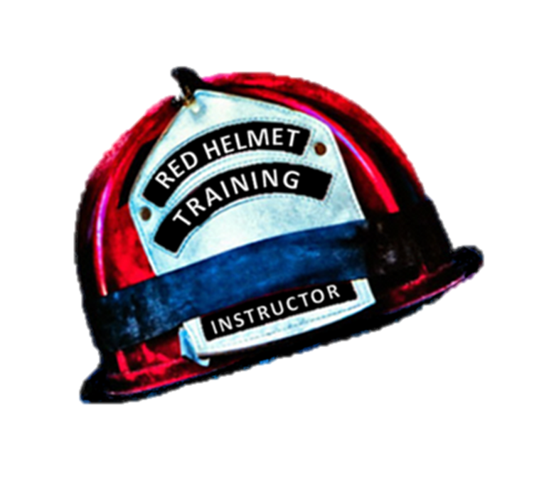
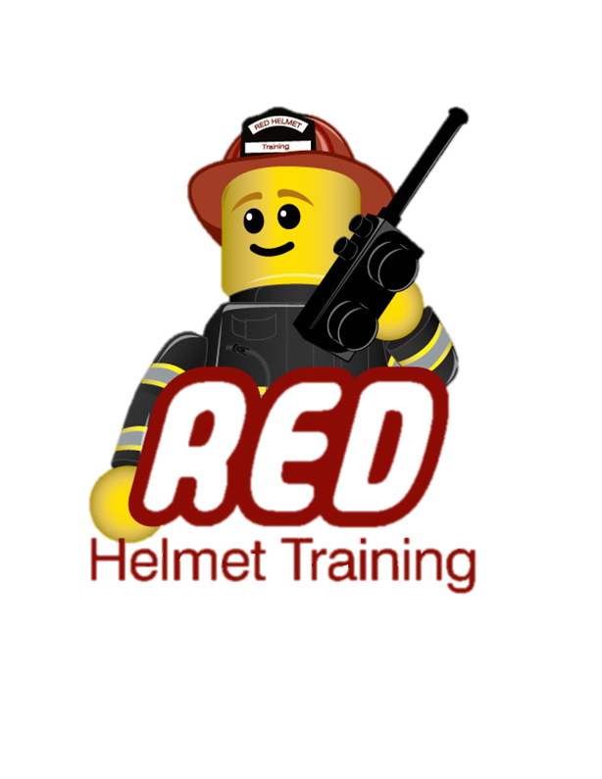
Red Helmet Training Group
Hazardous Materials Division

Announce: CSTI Haz-Mat Assistant Safety Officer

Dates: September 26th and 27th, 2015

Times: 8:00 a.m. – 5:00 p.m.

Location: Red Helmet Training Classrooms
10601 Church St, #107
Rancho Cucamonga, CA 91730

Instructor: Captain Dan Casner

Fees / Materials: $200.00 – Payable to Red Helmet Training
Covers cost of CSTI Materials and Certificate

Class Description: This course meets FIRESCOPE’s hazardous materials typing requirements of at least “one company member trained to a minimum of Assistant Safety Officer (ICS-HM-222-5) and shall meet or be equivalent to requirements found in Title 19 CCR 2520(r)”.
This class also meets NFPA 472 (2008) Chapter 11 – Competencies for Hazardous Materials Safety Officers.

Prerequisites: Hazardous Materials Technician or Specialist
Certification is required first day of class

To register for this course please visit the web site.
www.RedHelmetTraining.com

Red Helmet Training

Playing to Learn, Learning to Play



