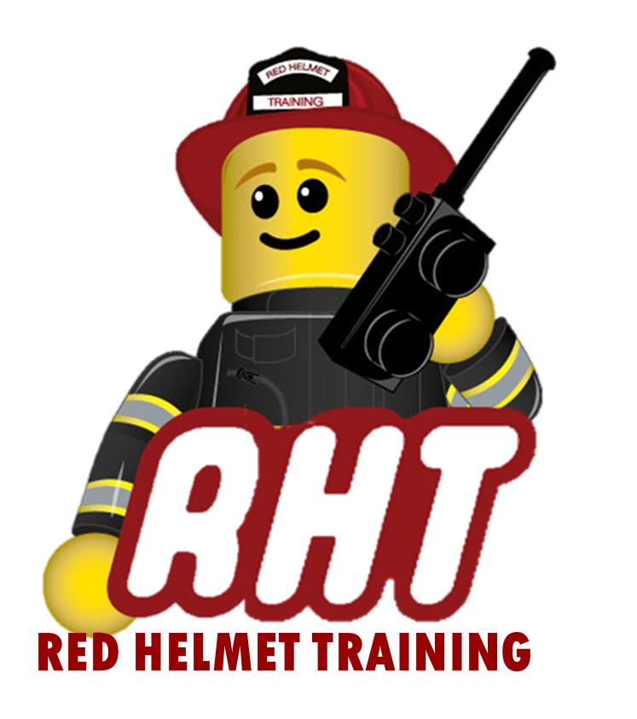
Red Helmet Training
Wildland Fire Courses

Announce: S-339 (AR) Division / Group Supervisor

Dates: October 16, 17, and 18, 2024

Times: 8:00 a.m. – 5:00 p.m.

Location: Red Helmet Training Classrooms
10601 Church Street #107
Rancho Cucamonga, CA 91730

Instructor: Jim Schiller and Duran Gaddy

Fees / Materials: $360.00 – Payable to Red Helmet Training
Covers cost of CSFM Training Material and CSFM S-339 (All Risk) FSTEP Certificate.

Class Description: This course teaches the student the management skills necessary to fill the position of Division/Group Supervisor within the framework of ICS. It does not teach tactics or strategy and refers to these only to enhance the particular management technique associated with them.

Prerequisites: ICS-300, AR or AH-330 Strike Team Leader
Please send in prerequisites with registration

THIS COURSE WILL REQUIRE 15 STUDENTS MINIMUM
To register for this course please visit the web site.
www.RedHelmetTraining.com

Red Helmet Training

Playing to Learn, Learning to Play


Red Helmet Training

Playing to Learn, Learning to Play
www.RedHelmetTraining.com

Course Registration Form

Student Name: Course:

Course Dates: Course Location:

Home Address: City: Zip:

Home Phone: Cell:

E-Mail Address:

Organization: Title:

To be added to the e-mail list for upcoming classes please visit the Red Helmet Training website.

Reservations are required for all classes unless specified. No phone reservations will be accepted.
You must send in a check or pay electronically to reserve your seat. If your department is paying for you to attend then we will shred your personal check or refund your electronic payment upon receipt of your department check. Checks are not processed until the last day of class so please plan accordingly. Checks should be dated for the last day of the course. Facility dress code is business casual or department uniform. Shorts and flip flops are not allowed.

You must call at least one week in advance to cancel or your fee will be retained. You will receive a confirmation e-mail once we have processed your reservation form, along with any course instructions. Any course prerequisites or materials required will be listed on the class flyer. These items are your responsibility to bring to class the first day. If you do not have them you will be dropped from class.

Reservations are on a first come basis unless spots are held by the sponsoring agency / department.
California State Fire Marshal CFSTES and CSTI certificates may take 6 to 8 weeks to process.

If you have any questions, please contact the primary instructor for the course.

Please complete this form and submit with your payment made payable to Red Helmet Training.

Mail all registration forms with payments to:

Red Helmet Training
10601 Church Street #107
Rancho Cucamonga, CA 91730

