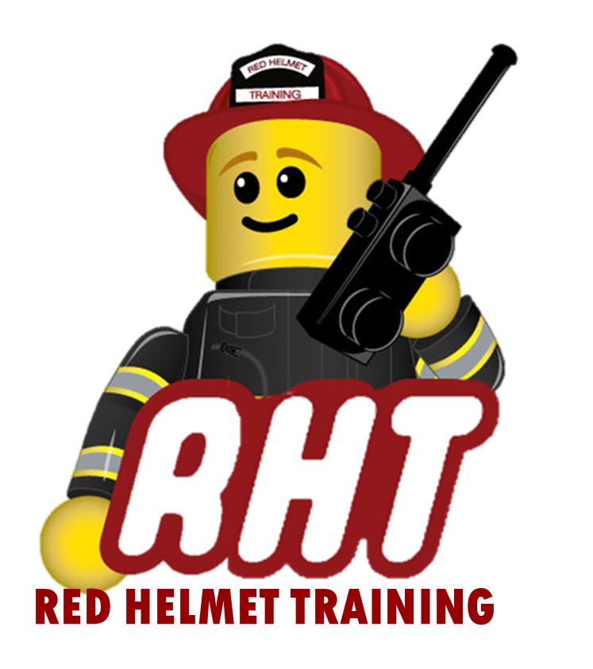

Red Helmet Training
Proudly Presents
L-280 Followership to Leadership

Dates: October 21st and 22nd, 2024 (Both Days)

Times: 8:00 a.m. – 5:00 p.m.

Location: Red Helmet Training
10601 Church Street #107,
Rancho Cucamonga, CA 91730

Instructor: RHT Staff

Fees / Materials: $300.00 – Payable to Red Helmet Training
Wildland PPE with web gear and boots.
Registration prior to August 16th is required

Class Description: This training course is designed as a self-assessment opportunity for individuals preparing to step into a leadership role. The course combines one day of classroom instruction followed by a second day in the field with students working through a series of problem-solving events in small teams FLAC (Field Leadership Assessment Course).
Topics include: leadership values and principles, transition challenges for new leaders, situational leadership, team cohesion factors, ethical decision-making, and after-action review techniques.

Pre-course Work: A short reading assignment with questions

http://www.redhelmettraining.com/L-280_Followership_to_leadership.html

To register for this course please visit the web site.


www.RedHelmetTraining.com

Red Helmet Training

Playing to Learn, Learning to Play

Red Helmet Training

Playing to Learn, Learning to Play
www.RedHelmetTraining.com

Course Registration Form

Student Name: Course:

Course Dates: Course Location:

Home Address: City: Zip:

Home Phone: Cell:

E-Mail Address:

Organization: Title:

To be added to the e-mail list for upcoming classes please visit the Red Helmet Training website.

Reservations are required for all classes unless specified. No phone reservations will be accepted.
You must send in a check or pay electronically to reserve your seat. If your department is paying for you to attend then we will shred your personal check or refund your electronic payment upon receipt of your department check. Checks are not processed until the last day of class so please plan accordingly. Checks should be dated for the last day of the course. Dress code for the facility is business casual or department uniform. No shorts or flip flops will be allowed.

You must call at least one week in advance to cancel or your fee will be retained. You will receive a confirmation e-mail once we have processed your reservation form, along with any course instructions. Any course prerequisites or materials required will be listed on the class flyer. These items are your responsibility to bring to class the first day. If you do not have them you will be dropped from class.

Reservations are on a first come basis unless spots are held by the sponsoring agency / department.
California State Fire Marshal CFSTES and CSTI certificates may take 6 to 8 weeks to process.

If you have any questions, please contact the primary instructor for the course.

Please complete this form and submit with your payment made payable to Red Helmet Training.

Mail all registration forms with payments to:

Red Helmet Training
10601 Church Street #107
Rancho Cucamonga, CA 91730

